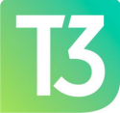
CAPITAL AREA MICHIGAN WORKS! T3 Council
Meeting Dates for 2024

Physical Meetings: The T3 Council will meet at 3:30 p.m. in the Big 3 Conference Room on the 1st Floor of Capital Area
Michigan Works! located at 2110 S. Cedar Street in
Lansing.
Virtual Meetings: Will be held via ZOOM.
Meeting ID: 938 5554 2198
Passcode: 502836
The T3 2024 meeting dates are:
January 16th
March 19th
May 21st
September 17th
November 19th

