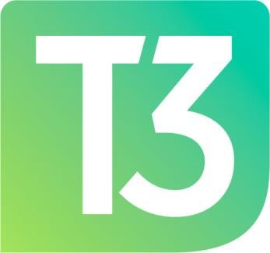

CAPITAL AREA MICHIGAN WORKS!

T3 Council

Meeting Dates for 2022

Physical Meetings: The T3 Council will meet at 3:30 p.m. in the Big 3 Conference Room on the 1st Floor of Capital Area Michigan Works! located at 2110 S. Cedar Street in Lansing.

Virtual Meetings: Will be held via ZOOM.
Meeting ID: 938 5554 2198
Passcode: 502836

The meeting dates are as follow:

January 25th

March 29th

May 24th

September 27th

November 15th

